SEIS632-02-Assignment3

Shivali Dalmia

Added StatExplore node to check for skewness and missing values.

Question1: How many clusters do you get?

Answer1: The data is grouped into 20 clusters.

Specified maximum number of clusters as 6.

Question2: Evaluate the output from the Segment Profile and explain the results in detail using the blue and red histograms and variable worth.

Answer2: The data is grouped into 6 clusters.

Question3: Evaluate the output from the Segment Profile and explain the results in detail using the blue and red histograms and variable worth.

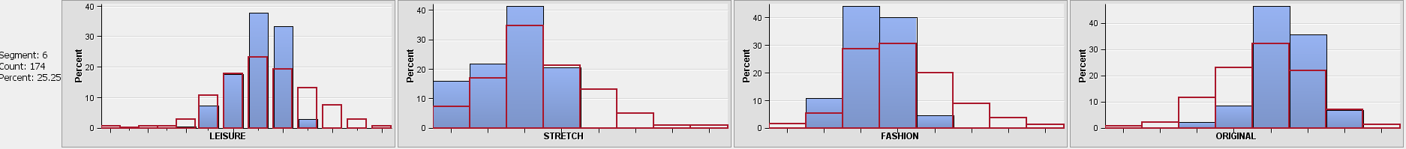Segment6:

|  |  |  |  |
| --- | --- | --- | --- |
| **Segment** | **Segment & Overall distribution comparison.** | **Variable Worth** | **Variability within segment.** |
| Segment6 | Leisure – Average number of jeans sold is close to the overall distribution average. 89% of jeans are sold in ranges 7,8 and 9 and 61% are sold in overall distribution.  Stretch- Average number of jeans sold is slightly lower than overall distribution average and 79% of jeans are sold in lower ranges(1,2,3,4) as compared 82% overall distribution.  Fashion- Average number of jeans sold is close to the overall distribution average. The distribution is tighter and more left aligned. 95% of jeans are sold in ranges 2,3,4 as compared to 75% in overall distribution (3,4,5).  Original-Average number of jeans sold is higher than the overall distribution average. The distribution is tighter and right aligned. 81% jeans are sold in higher ranges (5,6,7) as compared to 77% in overall distribution (4,5,6). | The variable worth for all Leisure , Stretch, Fashion and Original are very close to each other.  As per facts this segment has stores which sold leisure type of jeans more as compared to other types. | The variability is lowest for Leisure in this segment followed by Stretch, Fashion, and original types. |

Segment4

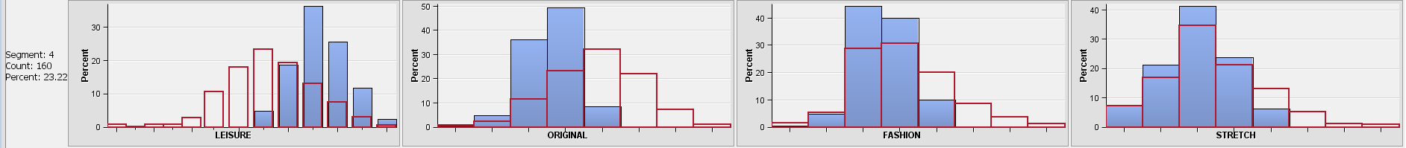

|  |  |  |  |
| --- | --- | --- | --- |
| **Segment** | **Segment & Overall distribution comparison.** | **Variable Worth** | **Variability within segment.** |
| Segment4 | Leisure – Average number of jeans sold is higher than the overall distribution average. 92% of jeans are sold in ranges 9,10,11,12 and 85% are sold in lower ranges 6,7,8,9 for overall distribution.  Stretch- Average number of jeans sold is close to overall distribution average. 95% of jeans are sold in lower ranges(1,2,3,4) as compared 81% in overall distribution.  Fashion- Average number of jeans sold is slightly lower than overall distribution average. The distribution is tighter and more left aligned. 94% of jeans are sold in ranges 3,4 as compared to 79% in overall distribution (3,4,5).  Original-Average number of jeans sold is lower than the overall distribution average. The distribution is tighter and more left aligned. 94% jeans are sold in higher ranges (3,4,5) as compared to 78% in overall distribution (3,4,5,6). | The variable worth for Leisure is highest, closely followed by Original. Fashion is lower by a high margin followed by Stretch.  This segment has stores which sold a greater number of leisure jeans. | The variability is lowest for Leisure in this segment followed by Original, Fashion, and Stretch types. |

Segment 2

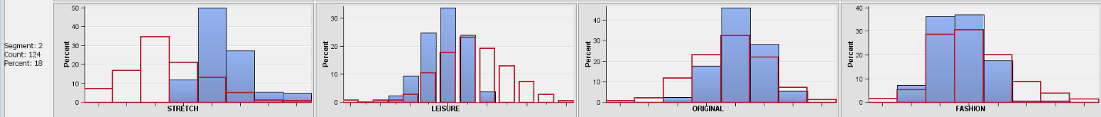

|  |  |  |  |
| --- | --- | --- | --- |
| **Segment** | **Segment & Overall distribution comparison.** | **Variable Worth** | **Variability within segment.** |
| Segment2 | Leisure – Average number of jeans sold is lower than the overall distribution average. 93% of jeans are sold in ranges 5,6,7,8 and 91% are sold in higher ranges 6,7,8,9,10 for overall distribution.  Stretch- Average number of jeans sold is much higher than overall distribution average. 95% of jeans are sold in higher ranges(4,5,6,7,8) as compared to 80% in lower ranges 1,2,3,4 of overall distribution.  Fashion- Average number of jeans sold is close to overall distribution average. 98% of jeans are sold in lower ranges 2,3,4,5 as compared to 93% in overall distribution (2,3,4,5).  Original-Average number of jeans sold is close to overall distribution average. 92% jeans are sold in middle ranges (4,5,6) as compared to 96% in overall distribution (3,4,5,6,7). | The variable worth for Stretch jeans is highest.  Others follow by a high margin.  This segment has stores which sold a greater number of stretch jeans. | The variability is lowest for Stretch in this segment followed by Leisure, Original, and Fashion types. |

Segment5

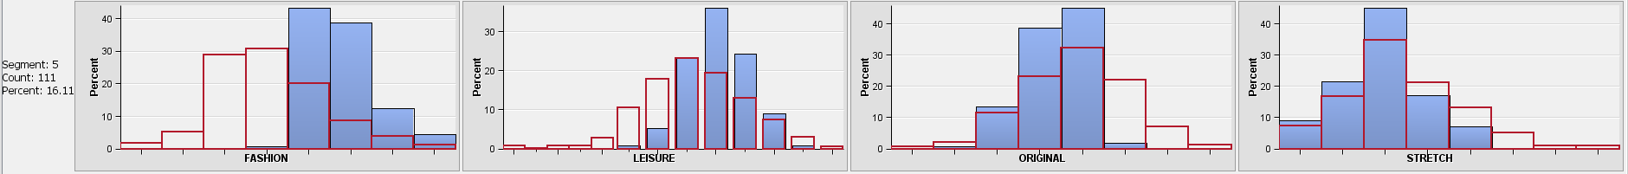

|  |  |  |  |
| --- | --- | --- | --- |
| **Segment** | **Segment & Overall distribution comparison.** | **Variable Worth** | **Variability within segment.** |
| Segment5 | Leisure – Average number of jeans sold is higher than the overall distribution average. 98% of jeans are sold in ranges 7,8,9,10,11 and 83% are sold in lower ranges 5,6,7,8,9,10 for overall distribution.  Stretch- Average number of jeans sold is close to overall distribution average. 94% of jeans are sold in lower ranges(1,2,3,4,5) as compared to 98% in lower ranges 1,2,3,4,5,6 ranges of overall distribution.  Fashion- Average number of jeans sold is higher than the overall distribution average. 97% of jeans are sold in ranges 5,6,7,8 and 83% are sold in lower ranges 2,3,4,5 for overall distribution.  Original-Average number of jeans sold is close to overall distribution average. 96% jeans are sold in middle ranges (3,4,5) as compared to 96% in overall distribution (3,4,5,6,7). | The variable worth for Fashion jeans is highest.  Others follow by a high margin.  This segment has stores which sold a greater number of Fashion jeans. | The variability is lowest for Fashion in this segment followed by Leisure, Original, and stretch types. |

Segment1

|  |  |  |  |
| --- | --- | --- | --- |
| **Segment** | **Segment & Overall distribution comparison.** | **Variable Worth** | **Variability within segment.** |
| Segment1 | Leisure – Average number of jeans sold is lower than the overall distribution average. 97% of jeans are sold in lower ranges 5,6,7,8 as compared to 94% are sold in higher ranges 5-12 for overall distribution.  Stretch- Average number of jeans sold is close to overall distribution average. 97% of jeans are sold in lower ranges(2,3,4,5) as compared to 92% in same range 2,3,4,5 of overall distribution.  Fashion- Average number of jeans sold is higher than the overall distribution average. 95% of jeans are sold in ranges 3,4,5,6,7 and 97% are sold in lower ranges 2,3,4,5,6 for overall distribution.  Original-Average number of jeans sold is higher than overall distribution average. The distribution is right aligned in higher ranges. 98% jeans are sold in middle ranges (5,6,7,8) as compared to 96% in overall distribution (1,2,3,4,5,6). | The variable worth for original jeans is highest.  Others follow by a high margin.  This segment has stores which sold a greater number of original jeans. | The variability is lowest for Original in this segment followed by Leisure, Fashion, and stretch types. |

Segment3

|  |  |  |  |
| --- | --- | --- | --- |
| **Segment** | **Segment & Overall distribution comparison.** | **Variable Worth** | **Variability within segment.** |
| Segment3 | Leisure – Average number of jeans sold is much lower than the overall distribution average. The distribution is tight and left aligned as compared to overall distribution. 100% of jeans are sold in lower ranges 1,2,3 as compared to 94% are sold in higher ranges 5-12 for overall distribution.  Stretch- No stretch jeans in this segment.  Fashion- Average number of jeans sold is much lower than the overall distribution average. The distribution is tight and left aligned. 100% of jeans are sold in lowest ranges 1 and 97% are sold in higher ranges 2,3,4,5,6 for overall distribution.  Original-Average number of jeans sold is lower than overall distribution average. The distribution is left aligned in lower ranges. 100% jeans are sold in middle ranges (1,2) as compared to 96% in overall distribution (3,4,5,6,7). | The variable worth for Fashion jeans is highest.  Others follow closely.  This segment has stores which sold a greater number of Fashion jeans. | The variability is lowest for Fashion in this segment followed by Leisure, Original. |